****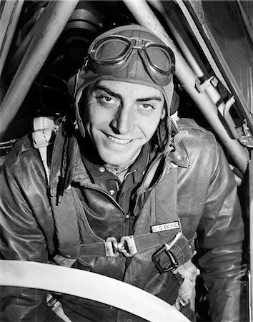

Pilots licence ID;

1867

Name: -Redacted-

D.O.B: 20/01/1949

Received Licence: -Redacted-

Skills: Advanced flying techniques, camouflage and concealment, navigation, celestial navigation

Background: Former Royal Navy pilot. Member of the Naval Boxing Team.

Honourary discharge from the forces.

Current occupation: Pilot for organisation –redacted-